Case report:
Combined orthodontic and surgical management of bimaxillary protrusion- a case report
¹ Dr. Monisha V, ² Dr. Falguni Mehta , ³ Dr. Renuka Patel, ⁴ Dr. Harshikkumar Parekh, ⁵ Dr. Rahul Trivedi,
⁶ Dr. Nipa Prajapati

Department of Orthodontics and Dentofacial Orthopaedics, Government Dental College and Hospital, Ahmedabad, Gujarat, India.

Abstract:
Class I bimaxillary protrusion is commonly seen malocclusion in Asian populations. This type of malocclusion is usually treated by extraction of upper and lower first premolars to create maximum space for the retraction of anterior teeth. A 18 years old female patient with similar malocclusion who had receded chin was treated by extraction of maxillary and mandibular first premolars for correcting proclination of the upper and lower anterior teeth followed by genioplasty for improving the facial proportion. Post treatment results showed significant improvement in facial profile and smile esthetics.
Keywords: Bimaxillary protrusion, genioplasty, facial appearance.
Corresponding author: Dr. Falguni Mehta

Introduction:
Class I bimaxillary protrusion is a common type of malocclusion. Proclination of upper and lower incisors and increased procumbency of the lips, are indications of bimaxillary protrusion. The causes of bimaxillary protrusion are diverse and include genetics as well as environmental factors like tongue volume, tongue and lip habits, and mouth breathing. The retraction of the maxillary and mandibular incisors to reduce the inclination of maxillary and mandibular anteriors and procumbancy of sift tissue are the main objectives of orthodontic corection for bimaxillary protrusion. The most frequent way of management is extraction of premolar teeth, followed by retraction of the anterior teeth using the maximum anchorage mechanics. Receded chin with orthognathic mandible leads to the convexity .To correct such deformities, genioplasty is the choice of treatment.
Case report:
A 18 years old female patient reported to the Department of Orthodontics and dentofacial Orthopaedics, Government Dental College and Hospital, Ahmedabad with the chief complaint of forwardly placed upper and lower front teeth and inability to close the lips. There was no history of dental trauma or oral habits. Extraoral examination revealed potentially competent lips, 4mm of incisor display at rest, deficient chin, convex facial profile and shallow mentolabial sulcus
Intraoral examination revealed Angle’s Class I molar and canine relation bilaterally, proclined upper and lower anterior teeth, mild crowding of lower anteriors, mesiolingually rotated 13, overjet of 3mm and overbite of 2mm. Panoramic radiograph showed presence of all permamant teeth upto 3rd molar, no periapical lesions and with no evidence of bone loss. Cephalometric analysis revealed skeletal Class I malocclusion (ANB=4° W angle=55°, Yen angle=118°, Beta angle=33°,) with average growth pattern (FMPA=29°, GoGn to SN=34°) and proclined and bodily forwardly placed upper and lower incisors (upper incisor to NA=32° and 10mm, lower incisor to NB=37° and 10mm). Based on clinical and cephalometric findings, the diagnosis was Angle’s Class I molar relation superimposed over skeletal Class I base relation with orthognathic maxilla and mandible with average growth pattern.

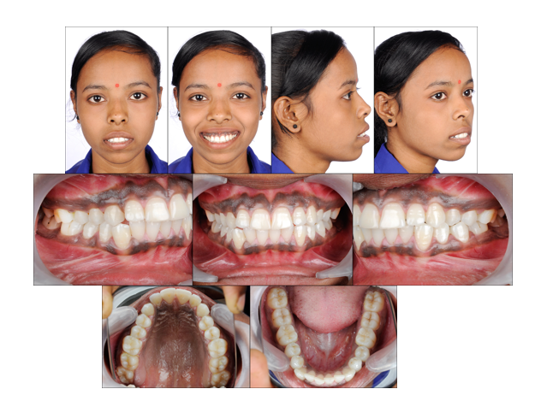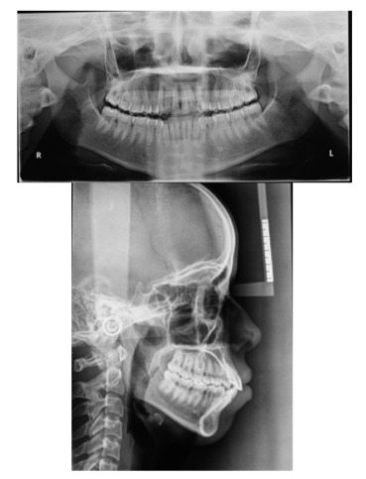
Figure 1: Pre-treatment photographs and radiographs

TREATMENT PLAN:
Cephalometric, photographic and model analysis revealed dentoalveolar proclination of maxillary and mandibular anterior teeth. So this case was treated with 0.022 MBT preadjusted edgewise appliance with extraction of upper and lower first premolars using TAD for absolute anchorage followed by genioplasty to address receded chin.
TREATMENT PROGRESS:
Patient was sent for extraction of upper and lower first premolars, after extraction 0.022” slot MBT appliance was bonded. Since mini implants can provide absolute anchorage, self driving type, conical orthodontic mini implant (1.5mm diameter and 8mm length) was placed into the buccal alveolar bone between the first molar and second premolar in both maxillary and mandibular arch. Levelling and alignment was done with a wire sequence of 0.016 Niti, 17*25 Niti and 19*25 Niti and 19*25 SS wire with crimpable hook between upper and lower lateral incisor and canine have been placed for retraction. Space closure was done with E- chain from crimpable hook to TAD(150-160gms of retraction force). After retraction prediction tracing (Surgical Treatment Objective) for advancement genioplasty have been done following which sliding advancement genioplasty of 8mm have been performed. Following this fixed bonded retainer from lateral to lateral in upper and canine to canine in lower arch and removable Begg’s retainers in upper and lower arch have been delivered.
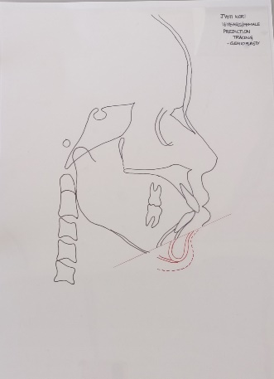
Figure 2: Surgical Treatment Objective

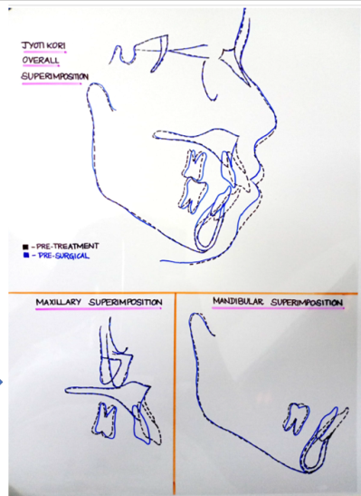
Figure 3: Superimposition
Figure 4: Post debonded photographs

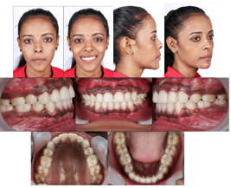

Table 1 Comparative cephalometric reading

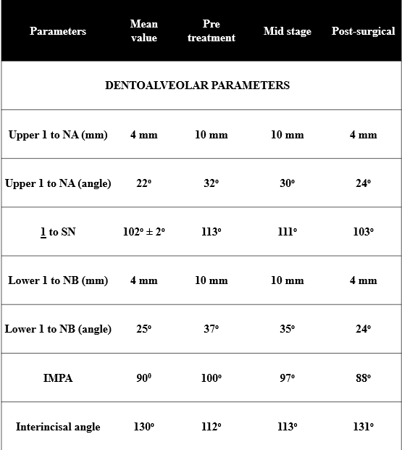

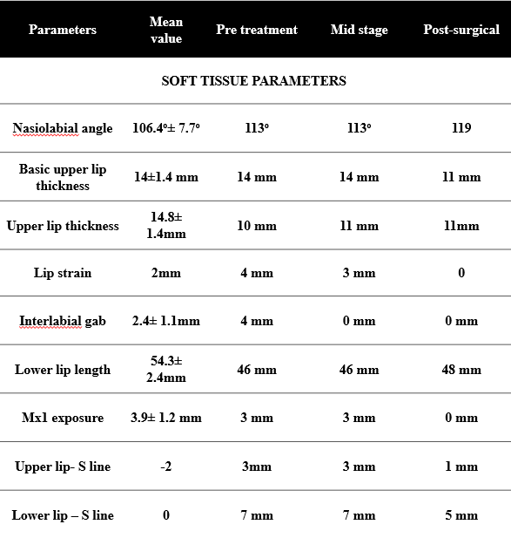

DISCUSSION:
Bimaxillary protrusion is common among various ethnic groups, the most affected population being Asians and American of African descent. It is characterised by severe proclination of upper and lower anterior teeth resulting in lip incompetency. Extraction of first premolars of both the arches followed by retraction of six anterior teeth will reduce the inclination of anteriors and improve the lip competency thereby improving the overall facial esthetics. In this case, proclination of both upper and lower anterior teeth has been reduced from upper incisor to NA=32° and 10mm to 24° and 4mm, lower incisor from NB=37° and 10mm to 24° and 4mm and interincisal angle from 112° to 131°. Soft tissue parameters such as lip strain, interlabial gap and upper incisor exposure has been significantly reduced. According to final superimposition, the maxillary and mandibular anterior teeth was retracted bodily by 6mm and no significant change in the position of maxillary and mandibular first molars were noted. No other skeletal or dental changes has been noticed. Even after retraction of the anterior teeth due to receded chin significant improvement in facial profile was not evident. Hence sliding genioplasty of 8mm has been done which improved the facial proportion. All these changes contributed to improving the facial profile which was more evident in the lower third of face. Primarily genioplasty has been used to achieve advancement of the inferior border of mandible for the correction of microgenia. Receded chin with orthognathic mandible and average growth pattern required sliding genioplasty for improvement of the facial profile.
CONCLUSION:
Class I bimaxillary dentoalveolar protrusion with receded chin can be managed well with extraction of all first premolars with TADs for absolute anchorage followed by advancement genioplasty to improve facial esthetics.

REFERENCES:
- Al Mamun MS, Hossain MZ. Management of Bimaxillary Protrusion A Case Report. Bangladesh Journal of Orthodontics and Dentofacial Orthopedics. 2013;3(2):32-4.
- Bills DA, Handelman CS, BeGole EA. Bimaxillary dentoalveolar protrusion: traits and orthodontic correction. The Angle Orthodontist. 2005 May;75(3):333-9.
- Halwa HK, Yadav SK, Dutta K, Gupta SK, Shrestha R, Shah AK. Bimaxillary Protrusion-A Case Report. Journal of Universal College of Medical Sciences. 2019 Jul 2;7(1):70-3.
- Ranjan R, Kumar S, Kumar R, Kumar A. Downward advancement genioplasty-a case report. Int J Oral Care Res. 2015;3:104-6.
- Jawale B, Lishoy R, Belludi A, Pharande A, Hattarki R, Prasad L. Correction of bimaxillary dentoalveolar protrusion in a growing male with class I malocclusion by extraction of premolars and profile improvement using conventional fixed orthodontic treatment-A case report on orthodontic camouflage. IP Indian Journal of Orthodontics and Dentofacial Research. 2020 Sep 15;6(3):157-62.

